Process for Identifying Gaps between the Kentucky Core Academic Standards (KCAS) and a School’s Current Curriculum 2-12-11
1  Individually, read KCAS for the grade level you currently teach.  Highlight what is new.  Underline anything confusing or what you are unsure how to teach.  Star (*) anything you would identify as a significant increase in rigor.  2  3  Individually, look back at your current curriculum.  Highlight what you have been teaching that is NOT in the KCAS for your grade level.  With your grade level group, discuss your findings.  Come to consensus on what does NOT show up in the KCAS for your grade level. CHART & POST | 12  K  1  2  3  4  5  Teachers across all grade levels participate in a carousel activity to review the charts.  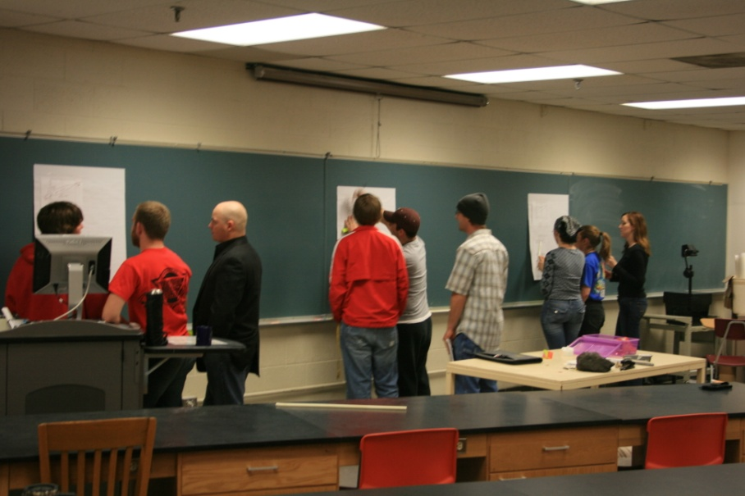  - Use a sticky note to identify what shows up now in the KCAS at your grade level.  - Add a sticky for any standard you’d like to learn more about. | Back in your grade level group with your chart, answer the question below.  Has what you charted been identified  in a previous grade’s KCAS?  YES NO  This is a gap!  This is not a gap, but discussion needs to occur in your district. Consult the Crosswalk to double check. See next steps below.  Identify which grade levels must address the gap.  1  2  3  Identify the gap. Identify grade levels for addressing the gap. Identify teachers as resources.  Use the Crosswalk to double check your findings.  Complete the Identified Gap sheet.
Collaborate to . . . identify gaps that may occur for new content in which students will miss scaffolded instruction at previous grades.
brainstorm ideas & develop a plan for addressing the identified gaps. Set priorities.
find effective ways to increase rigor in instruction to address standards you identified as more rigorous.
have conversations about content in current curriculum, but not included in the new standards.
learn from others who have taught content that may be new for you.
What you need

Grade level KCAS placemats
Current school curriculum documents
Chart paper, Markers,
Sticky, notes, Highlighters
Identified Gap & PD sheets for groups
Access to on—line KCAS Crosswalk

