Highly Effective Teaching and Learning in Kentucky

Overview Guide

Why so much emphasis around "Highly Effective Instruction"?
The Kentucky Department of Education entered into a partnership with Harvard University, the Wallace Foundation, Jefferson, Daviess, Boone, and Kenton Counties in 2005 called the Executive Leadership Program for Educators (ExEl). The focus of the work was to help districts and state departments of education bring high quality teaching and learning to scale. Along with the four ExEl districts, 48 additional districts in the state are using information from the project to develop district and school partnerships focused on highly effective instruction through professional learning communities. It is our hope that the knowledge gained from this valuable partnership will be sustained in many ways to help provide support for educators and students throughout the Commonwealth.

The ‘starting point’ (some assertions presented by Tony Wagner based on his work with schools in the United States)
Student achievement will not improve unless and until teaching improves. Higher standards, more testing, smaller schools, etc. do not, by themselves, improve teaching.
Teachers, working alone, with little or no feedback on their instruction, will not be able to improve significantly—no matter how much professional development they receive.
The challenge of change leadership is to create a “system” for continuous improvement of instruction, supervision, and instructional leadership.
-Tony Wagner
Further research suggests…
The factors within the control of districts and schools that have the most significant impact on student learning are:
- High-quality instructional practice
- Well-designed curriculum, assessments and instructional materials aligned to standards
- Strong school leadership – through galvanizing effort around a shared vision of high quality teaching, learning and content; setting ambitious goals with monitoring and feedback systems to achieve this vision; then constructing all elements of organization to facilitate rather than constrain success.
So what really is the ‘instructional core’?
"You don't change performance without changing the instructional core," states Anrig Professor Richard Elmore. "The relationship of the teacher and the student in the presence of content must be at the center of efforts to improve performance."

What this means, says Elmore, is there are basically only three ways you can increase learning and performance:

- increase the knowledge and skill of teachers
- change the content
- alter the relationship of the student to the teacher and the content

"The instructional core helps us identify where we're trying to improve," explains Elmore. "The teacher, the student, the content – if you change one, you have to change them all. You can't alter the skill and knowledge of the teacher when you stay in a low-level curriculum. If you alter the content without changing the skill and knowledge of teachers, you are asking teachers to teach to a level that they don't have the skill and knowledge to teach to. If you do either one of those things without changing the role of the student in the instructional process, the likelihood that students will ever take control of their own learning is pretty remote."

Elmore advocates focusing on the instructional core in schools (the teacher and the student in the presence of content). He cautions districts and policy makers, "If you push on an organization and you don't have a theory about how it shows up in teaching and learning, you're basically causing people to do rain dances."

What is the “Instructional Core”?
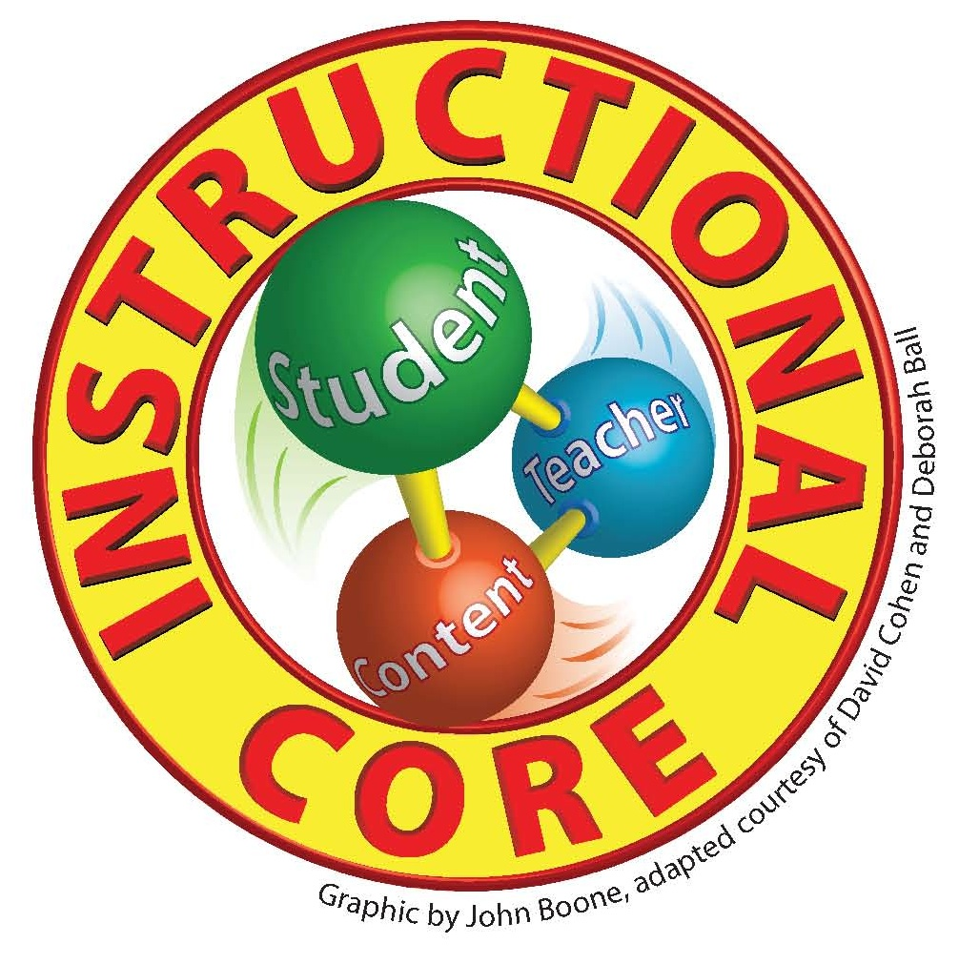
Student
The work a student does, with guidance and assistance from a teacher, to learn and apply content, to reflect on what and how they have learned, and to be able to assess their own learning and performance against expected learning and performance.
Teacher
The work a teacher does to create the conditions and develop student capacity to learn and apply content - based on a clearly defined instructional models that inform the tasks they select or design, the pedagogy they use, how they support and monitor learning, what they expect students to complete and how they judge and support a proficient performance.
Content
The concepts, thinking and reasoning processes, skills, and procedures that students are expected to learn and apply in specific content areas and at specific grade levels. These are defined by state and local standards and assessments.
Note: the concept of the "Instructional Core" is a fundamental component of Harvard's Public Education Leadership Project (PELP). To learn more about PELP and the instructional core, click here: http://www.hbs.edu/pelp/framework.html
The Kentucky Department of Education has developed a theory of action that demonstrates how to provide support for the instructional core. The theory of actions is as follows:
Students will only be able to learn and apply the knowledge, processes and skills defined by Kentucky standards if they are effectively engaged with challenging content under the guidance of a skilled, knowledgeable and responsive teacher who holds them to clear, high expectations.
Teachers will only be able to engage students with challenging content in ways that produce effective learning results if they are supported with high quality, aligned instructional resources and with on-going, continuous opportunities to learn about, generate and receive feedback about, and reflect on the quality of their instruction and the work of their students within a school and district culture of clear, high, accountable expectations.
School and district leadership will only be able to achieve high quality instruction and continuously improving academic achievement if they galvanize effort around a shared vision of what constitutes high quality teaching, learning, and content, set ambitious goals with monitoring and feedback systems to achieve this vision, and construct all elements of their organization to facilitate rather than constrain success.
Why begin with the Characteristics of Highly Effective Teaching and Learning?
Imagine how frustrating culinary school would be if the only feedback a student chef received was “Make this taste better.” Now imagine the same problem applied to school improvement. How does one become a ‘better’ teacher? What are the characteristics of effective teaching that distinguish the most effective teachers? How does one become a ‘better student’? What are the characteristics of effective learning that distinguish the most effective students?
Clearly teachers, administrators, mentors and evaluators would benefit from a defined set of characteristics describing high quality teaching and learning. In an effort to create such a tool the Kentucky Department of Education has began to compile and organize the Characteristics of Highly Effective Teaching and Learning. A common set of characteristics as well as content specific characteristics are currently being developed and reviewed.
The Characteristics of Highly Effective Teaching and Learning are intended to create a common point of reference for discussing effective practices in teaching and learning by describing the role of the teacher and student in an exemplary instructional environment. It allows teachers, administrators and evaluators to have discussions around a set of research-based descriptors of effective classroom practice. The document is divided into five components. Each of these components is supported with a list of characteristics of effective teacher practice and student actions. The Characteristics are based upon some of the most current findings from several resources.
- Learning Climate
- Classroom Assessment and Reflection
- Instructional Rigor and Student Engagement
- Instructional Relevance
- Knowledge of Content
How can the Characteristics of Highly Effective Teaching and Learning be used?
The Kentucky Department of Education is currently in the process of fully developing characteristics to support all content areas. Once the characteristics were developed, they were reviewed and validated by members selected by content teams (with strong representation of post-secondary reviewers) and then posted on the KDE web site.

It is our hope that schools and districts will use these characteristics and resources to provide support for the instructional core in Kentucky classrooms and also think about the further support needed to implement high quality teaching and learning for every student in Kentucky.

We recommend that these characteristics and resources be used to support discussions in professional learning communities that are focused on learning about what good teaching and learning looks like to establish common understanding. It is important to mention that increased focus on student learning should be the primary goal or discussion point in using the characteristics, research and aligned resources. We hope the characteristics and supporting resources will help teachers implement high quality teaching and learning for all students.

The characteristics will eventually be available as a teacher-friendly interactive resource that will connect users to information that illustrate, support or explain the characteristics. Content teams have been looking at current research to build the characteristics as a starting place. The teams are also in the process of creating and gathering resources to illustrate the characteristics. We appreciate your patience as we fully develop the characteristics and align research and resources. We are looking forward to seeing models of practice that demonstrate how this work is being implemented in classrooms across the Commonwealth of Kentucky.

Kentucky Teacher has also agreed to promote this work through their publication and we will continue to highlight connections to high quality teaching and learning. Kentucky Teacher can be found on-line at the following link:

http://www.education.ky.gov/KDE/HomePageRepository/Publications/Kentucky+Teacher.htm

