Components of Highly Effective Teaching and Learning

Learning Climate: a safe environment supported by the teacher in which high, clear expectations and positive relationships are fostered; active learning is promoted
Classroom Assessment and Reflection: the teacher and student collaboratively gather information and reflect on learning through a systematic process that informs instruction
Instructional Rigor and Student Engagement: a teacher supports and encourages a student’s commitment to initiate and complete complex, inquiry-based learning requiring creative and critical thinking with attention to problem solving
Instructional Relevance: a teacher’s ability to facilitate learning experiences that are meaningful to students and prepare them for their futures
Knowledge of Content: a teacher’s understanding and application of the current theories, principles, concepts and skills of a discipline

References

Learning Climate:
Brookover, W. B.,Schweitzer, J. H., Beady, C., Flood, P., & Wisenbaker, J. M. (1978). Elementary

school social climate and school achievement. American Educational Research Journal,

15,301-318.

Cotton, K. (1996). School size, school climate, and student performance (School Improvement

Research Series, Close-Up No. 20). Portland OR: Northwest Regional Educational

Laboratory.

Felner, R. D., Ginter, M., & Primavera, J. (1982). Primary prevention during school transitions:

Social support and environmental structure. American Journal of Community

Psychology, 10, 277-290.

Kentucky Department of Education. (2006) Standards and Indicators for School Improvement. KY: Author.
New Detroit: The Coalition. (2003). A progress report:School improvement in the Detroit Public
Schools. East Lansing:Michigan State University.
Philadelphia Citizens for Children and Youth and the Alliance Organizing Project. (2001, June).

The City-Neighborhood Schools Initiative: Improving school climate is everybody’s

business.

Resnick, M.D., et al. (1997). Protecting adolescents from harm: Findings from the National

Longitudinal Study on Adolescent Health. Journal of the American Medical Association,
278, 823-832.

Scales, P. C., & Leffert, N. (1999). Developmental assets. Minneapolis, MN: Search Institute.
Sebring, PB, Allensworthy, E., Bryk, A.S., et.al. The Essential Supports for School Improvement. A

report of the Consortium on Chicago School Research at the University of Chicago, 2006,

http://ccsr.uchicago.edu.

Senge, P.M. (1994). The fifth discipline: The art and practice of the learning organization. New
York: Currency Doubleday.
Western Alliance for the Study of School Climate. (No date). Introduction to assessment at the
WASSC. www.calsttela.edu/centers/schoolclimate/assesssment.html
Young, N., Gardner, S., Coley, S., Schorr, L., & Bruner, C. (1994). Making a difference: Moving to
outcome-based accountability for comprehensive service reforms (Resource Brief 7).
Falls Church, VA: National Center for Service Integration.

Classroom Assessment and Reflection:
Black, P., & Wiliam, D. (1998). Inside the Black box: Raising Standards Through Classroom
Assessment. Phi Delta Kappan. Association for Supervision & Curriculum Development.
Educational Testing Service, Stiggins, R., Arter, Judith A., Chappius, J., & Chappius, S. (2007).
Classroom Assessment for Student Learning: Doing It Right--Using It Well. Prentice Hall.
Marzano, Robert J., (2003). What Works in Schools: Translating Research into Action.
Marzano, Robert J. (2006). Classroom Assessment & Grading That Work. Association for
Supervision & Curriculum Development.
Zemelman, S., Daniels, H., & Hyde, A. (2005). Best Practice, Today's Standards for Teaching and
Learning in America's Schools. Heinemann.
Several other papers by Dylan Wiliam

Instructional Rigor and Student Engagement:
Blackburn, B. (2008, October 8). Rigor is Not a Four Letter Word. Retrieved from
eyeoneducation: eyeoneducation.com
Daggett, W. R. (2008, October 8). Rigor and Relevance Handbook. Retrieved from
www.natpd.com/present/files/mass
Schlechty, P. C. (2002). Working on the Work: An Action Plan for Teachers, Principals, and
Superintendents. San Fransisco: Jossey-Bass.
Silver, H. F. & Strong, R.W. (2001). Teaching What Matters Most. Alexandria, VA: Association
for Supervision and Curriculum Development.
Wiggins, G. & McTighe, J. (2004). Understanding by Design Professional Development
Workbook. Alexandria, VA: Association for Supervision and Curriculum Developm
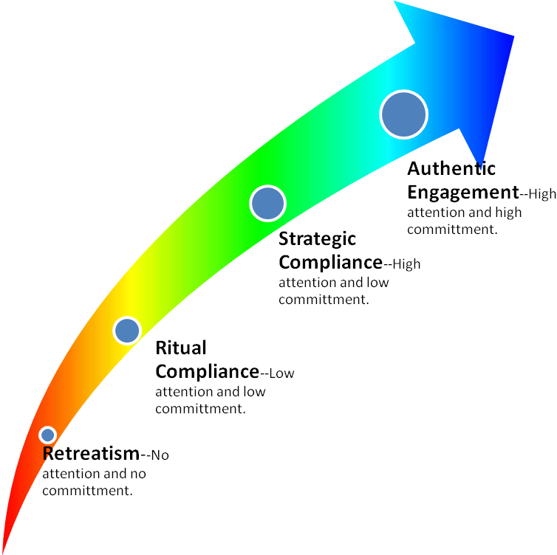
Example: Memorization without application.
Example:
Write the spelling words five times each and use the words in a sentence.
Example:
A read aloud that is devoid of questions or purpose. Students may have high interest but low commitment due to a lack of purpose.
Example:
Literature circles promote ownership of the learning. Students who assume roles within the literature circle have high attention and high commitment.
* Discussion Director
Questions
* Vocabulary Enricher
Clarifies
* Literary Luminary
Examines
*Checker
Evaluates

Student Engagement
* The graphic is intended to illustrate the levels of a student’s engagement in relation to Bloom’s Taxonomy. This taxonomy is not meant to be linear, but rather building blocks that might occur to reach higher levels of student engagement. (e.g., Memorization of dialog is critical for a dramatic performance, thus remembering leads to creating.)
* Levels of Engagement adapted from Phil Schlechty’s Working on the Work.

Rigor
Understanding
Remembering
Applying
Analyzing
Evaluating
Creating

Instructional Relevance:
Brophy, J. (2004). Motivating students to learn (2nd ed.). Boston, MA: McGraw Hill.
Cannon, M., Umble, K., Steckler, A., & Shay, S. (2001). "We're living what we're learning":
Student perspectives in distance learning degree and certificate programs in public health.
Journal of PublicHealth Management and Practice, 7(1), 49 - 60.
Daggett, W. R. (2005) Achieving Academic Excellence through Rigor and Relevance.
Gagné, R.M., & Driscoll, M.P. (1988). Essentials of learning for instruction, (2nd Ed). New Jersey.
Prentice Hall.
Gagné, R.M., & Medsker, K.L. (1996). The conditions of learning: Training applications. Belmont.
Wadsworth Thompson Learning.
Keller, J. (1983). Motivation design of instruction. In C. Reigeluth (Ed.), Instructional-design theories and
models: An overview of their current status (pp. 383 - 434). New Jersey: Lawrence Erlbaum Associates.
Kentucky Department of Education. (2000) Kentucky’s Guide for Reflective Classroom Practices: A Self
Assessment Tool for Teachers. KY: Author
Kentucky Department of Education. (2006) Standards and Indicators for School Improvement. KY: Author
International Center for Leadership in Education. (2006) Instructional Strategies: How to teach rigor and
relevance. Retrieved from www.natpd.com/present/files/Mass
International Center for Leadership in Education. (2006). [Rigor/Relevance Framework] Retrieved from
http://www.leadered.com/rigor.html
Smith, P., & Ragan. (1999). Instructional design, (2nd ed.). New York: John Wiley & Sons, Inc.
Sternberg, R. & Subotnik, R., eds. (2006). Optimizing Student Success with the Other Three Rs:Reasoning
Resilience, and Responsibility. Greenwich, CT: Information Age Publishing.
Wagner, T., Kegan, R. , Lahey, L., Lemons, R., Garnier, J., Helsing, D., Howell, A., Rasmussen, H. (2006).
Change Leadership: A Practical Guide to Transforming Our Schools. San Francisco: Jossey Bass.

Knowledge of Content:
Akiba, M., LeTendre, G.K., & Scribner, J.P. (2007). Teacher quality, opportunity gap,
nationalachievement in 46 countries. Educational Researcher, 36(7), 369-387.
Berry, B. (2004). Recruiting and retaining “highly qualified teachers” for hard-to-staff schools.
NASSP Bulletin, 638(87), 5-27.
Carr, M. (2006). The determinants of student achievement in Ohio’s public schools. A policy
report. Retrieved September 5, 2008 from
http://www.buckeyeinstitute.org/docs/Policy_ReportDeterminants_of_Student_Achievement_in_Ohio.pdf

Coggshall, J. G. (2007). Components of the communication framework. Washington, DC.

National Comprehensive Center for Teacher Quality. Retrieved July 16, 2008, from

NCCTQ.

Coleman, J. S., Campbell, E. Q., Hobson, C. J., McParland, J., et al. (1966) Equality of

educational opportunity. Washington, DC: U.S. Government Printing Office.

Creswell, J. W. (2003). Research design qualitative, quantitative, and mixed methods

approaches, Second edition. Sages Publication, Inc. Thousand Oaks, CA.

Creswell, J. W. (2007). Qualitative inquiry and research design Choosing among five

approaches, Second edition. Sage Publication, Inc. Thousand Oaks, CA.

Darling-Hammond, L. (1998). Teacher learning that supports student learning. Educational

Leadership 55, 6-11.

Darling-Hammond, L. & Young’s, P. (2002). Defining "Highly Qualified Teachers": What Does

"Scientifically-Based Research" Actually Tell Us? Educational Researcher, 31(9), 13-25.

Education Professional Standards Board. (2007). Identifying “highly qualified” teachers

pursuant to the No Child Left Behind Act of 2001. Retrieved July 28, 2008, from

http://www.kyepsb.net/KyTQPlan.asp .

Education Professional Standards Board. (2008). Identifying “highly qualified” teachers

pursuant to the No Child Left Behind Act of 2001 frequently asked questions. Retrieved

September 11, 2008, from

http://www.kyepsb.net/documents/NCLB/HQ%20Addenda%20revised%200508.pdf .

Education Professional Standards Board. (2008). Highly qualified frequently asked questions.
Retrieved July 28, 2008, from http://www.kyepsb.net/KyTQPlan.asp .

Education Professional Standards Board. (2006). Kentucky revised highly qualified teacher plan

2006. Retrieved July 28, 2008, from http://www.kyepsb.net/KyTQPlan.asp .
Fenstermacher, G.D., & Richardson, V. (2005) The Teachers College Record. 107(1), 186-213.
Goddard, R. D., Hoy, W. K., & Hoy, A. W. (2000). Collective teacher efficacy: Its meaning,

measure, and impact on student achievement. American Educational Research Journal.

37(2),479-507.

Goe, L., (2007). The link between teacher quality and student outcomes: A research synthesis.

Washington, DC: National Comprehensive Center for Teacher Quality.
Goe, L., & Stickler, L.M. (2008). Teacher quality and student achievement: Making the most of

recent research. Washington, DC: National Comprehensive Center for Teacher Quality.
Goldhaber, D. D., & Brewer, D. J. (1999). Does teacher certification matter? High school teacher

certification status and student achievement. Educational Evaluation and Policy

Analysis, 22(2), 129-145.

Hanushek, E. A., Kain, J. F., & Rivkin, S. G., (2005). Teachers, schools, and academic

achievement. Economica, 73(2), 417-458.

Harris, A. & Muijs, D., (2003). Teacher leadership and school improvement. Education Review,

16(2).
Heck, R. H., (2007). Examining the relationship between teacher quality as an organizational

property of schools and students’ achievement and growth rates. Educational

Administration Quarterly, 43(4), 399-432.

Hibpshman, T. (2004). Considerations related to setting cut scores for teacher tests. Retrieved

July 3, 2008, from http://www.kyepsb.net/dataresearch/journals/index.asp .
Hirsh, S. (2005). Theory into practice. 44(1), 38-44.
Ingersoll, R. M., (2002). Out-of-field teaching, educational inequality and the organization of

schools: An exploratory analysis. University of Washington: Center for the Study of

Teaching and Policy.

Jerald, C. D. (2002), All talk, no action: Putting an end to out-of-field teaching. Washington D.C.

Education Trust Inc.
Kannapel, P. J., & Clements, S. K. (2005). Inside the black box of high performing high-poverty

schools. A report of the Prichard Committee for Academic Excellence. Lexington,
Kentucky. Retrieved September 15, 2008 from

http://www.prichardcommittee.org/Portals/1059/Inside%20the%20Black%20Box.pdf .

Kentucky Department of Education, (2008). Kentucky performance reports. Retrieved July 8,

2008, from
http://www.education.ky.gov/KDE/Administrative+Resources/Testing+and+Reporting+/Report/Kentucky+Performance+Reports/ .

Kentucky Department of Education, (2000). Results matter: A decade of difference in

Kentucky’s public schools. Retrieved March 8, 2006 from http://www.education.ky.gov .

Knapp, M. S., Shields, P. M. (1995). Academic challenge in high-poverty classrooms. Phi Delta

Kappan, 76(10), 770. Retrieved May 5, 2008 from

http://web.ebscohost.com.exproxy.uky.edu/ehost/detail?vid=7&hid=107&sid=942732460

Logan, J. P. (2005). National board certification and teacher leadership. Lexington, KY:

University of Kentucky.

McCaffrey, D., Lockwood, J.R., Koretz, D. M., & Hamilton, L.S, (2003). Evaluating value

added models for teacher accountability. Retrieved July 15, 2008 from

http://www.kyepsb.net/documents/Stats/Journals/RAND_VAM_monograph.pdf .

Presely, J. B., White, B. R., and Gong, Y. (2005). Examining the distribution and impact of

teacher quality in Illinois. Policy Research Report: IERC 2005-2. Retrieved July 3, 2008

fromhttp://ierc.siuc.edu .

Rice, J. K., (2003). Understanding the effectiveness of teacher attributes. L. Goffredi & J.

Procopio (EdS.), Teacher quality. Washington, DC: Economic Policy Institute.
Sanders, W. L., (2000). Value-added assessment from student achievement data: opportunities

and hurdles. Journal of Personnel Evaluation in Education, 14(4), 329-339.

Sanders, W. L., & Horn, S. P., (1998). Research findings from the Tennessee value-added

assessment system (TVASS) database: Implications for educational evaluation and

research.Journal of Personnel Evaluation in Education, 12(3), 247-256.

The Center for Public Education, (2005). Teacher quality and student achievement research

review. Retrieved July 25, 2008,

fromhttp://www.centerforpubliceducation.org/site/c.kjJXJ5MPIwE/b.1510983/k.2A6A/Teacherquality_and_student_achievement_research_review.htm .

U.S. Department of Education (2002). Meeting the highly qualified teachers challenge: The

secretary's annual report on teacher quality. Retrieved July 3, 2008, from LexisNexis

Academic Website:

http://www.lexisnexis.com.ezproxy.uky.edu/us/lnacademic/search/homesubmitForm.do .

Wenglinsky, H., (2004). Closing the racial achievement gap: The role of reforming instructional

practices. Education Policy Analysis Archives, 12(64). Retrieved March 27, 2006 from

http://epaa.asu.edu/epaa/v12n64/.

Wright, P. S., Horn, S. P., & Sanders, W. L. (1997). Teacher and classroom context effects on
student achievement: Implications for teacher evaluation. Journal of Personnel
Evaluation in Education, 11, 57-67.

