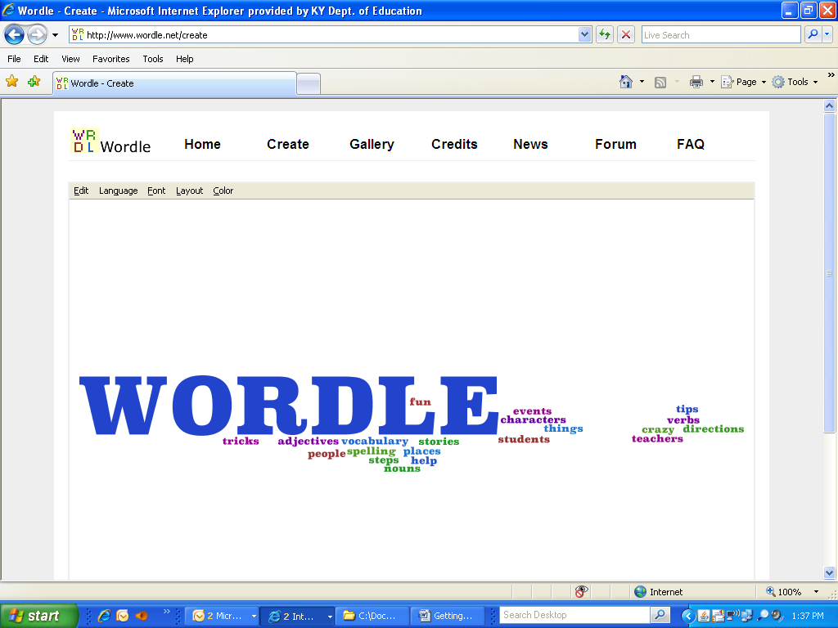
- Go to http://www.wordle.net

- Click on Create 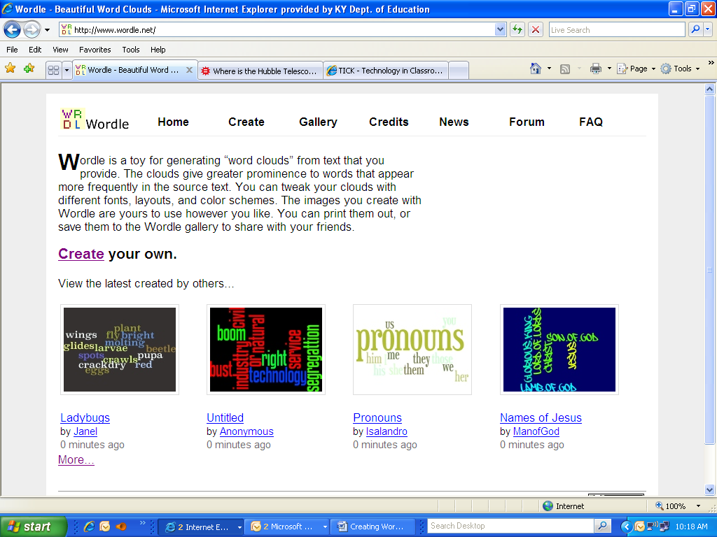

- Type in the text you want – or copy and paste text.
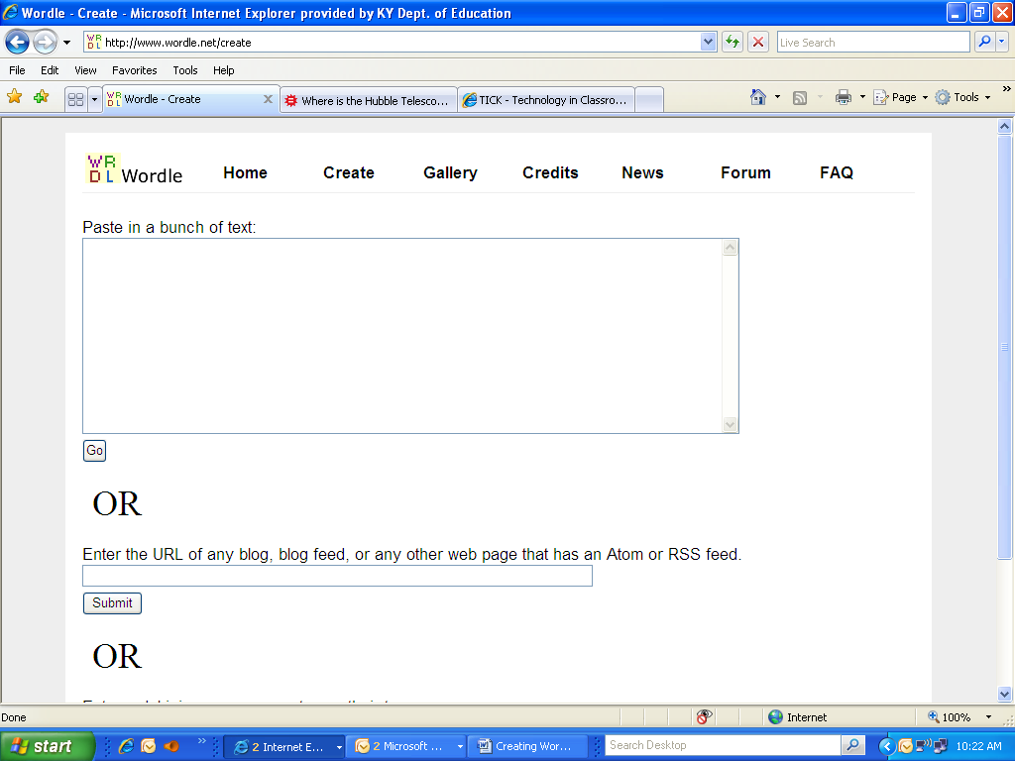

- Once you have all of the text in the box click on the GO button

- Click on the RANDOMIZE button until it is the format you want

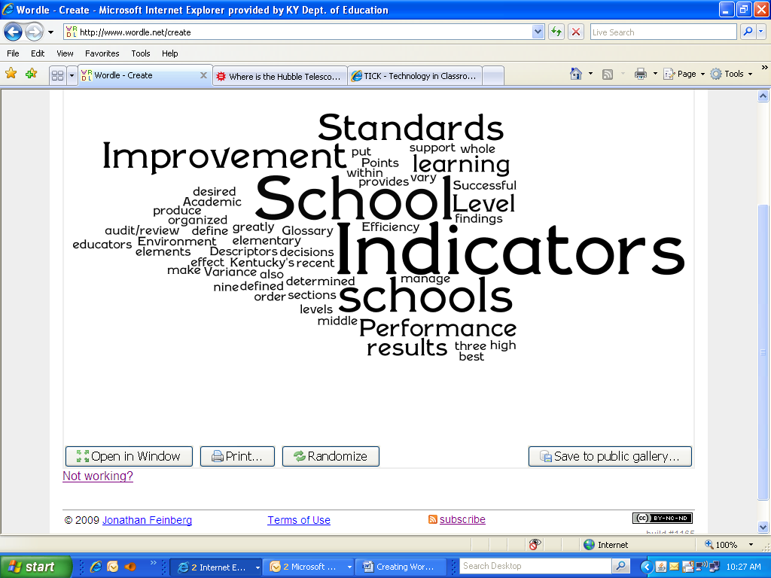

If you want to copy the info to Word

- Hold down the CTRL key and press the PRINT SCREEN key – this copies the entire screen

- Go to Word and hold the CTRL key and press the V key to paste the image into Word

- Crop the image to only show the Words

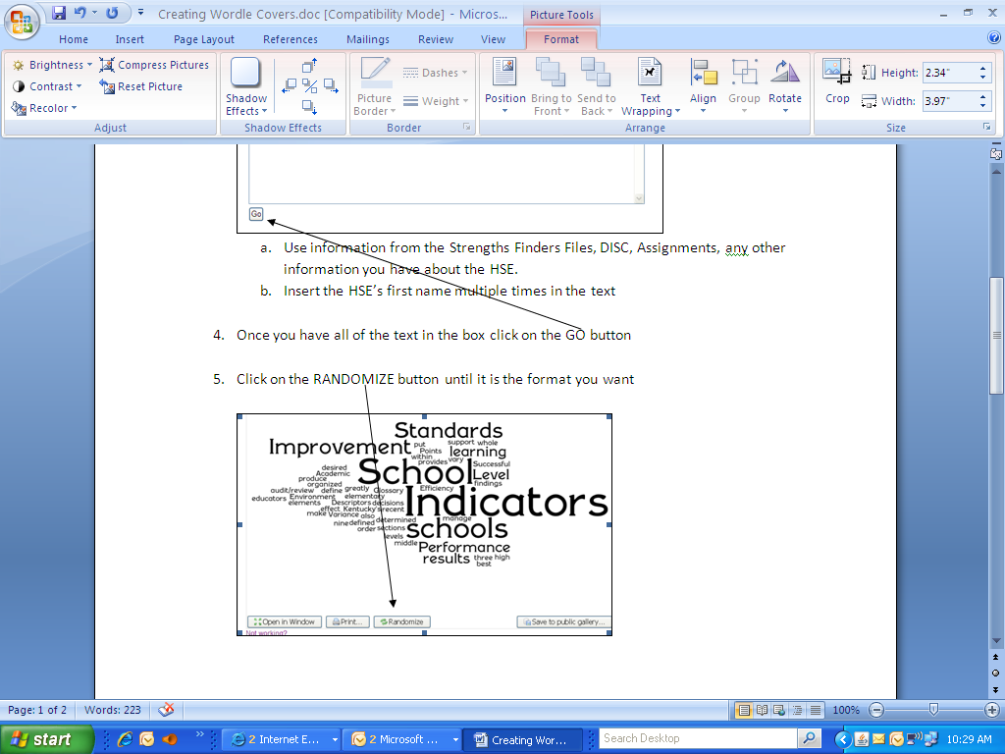
  - Click on the Picture tool at the top
  - Click on the Crop icon in the Picture Tool bar
  - Click on the corners or handles at the edge of the picture, hold and move in until you are at the place you want to stop “cropping” or cutting.
  - Do this with each “handle” where you want to cut out extra parts of the image

- Resize the picture to the desired size.

